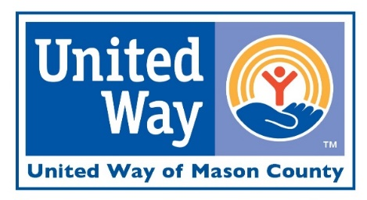

ENDORSEMENT EMAIL SAMPLE

Dear (NAME):

At United Way of Mason County, they know the struggles that so many in this community experience. They hear them firsthand through our Mason County Family Link program and the Lakeshore Employer Resource Network, from phone calls from those needing help, and from organizations sharing the struggles they face.

They hear stories from employees like Jim, who works full-time but can’t make ends meet. Who told the LERN Success Coach that he’s a single dad with two children and he can’t afford to fix his car that broke down. It can be a struggle when you don’t have your car, but when you depend on it for work and getting kids to school, it makes it an absolute necessity. UWMC was able to help Jim through the LERN interest free auto loan program – he was able to get his car fixed and pay the loan back through payroll deductions.

Or stories like Claire, who is a student that needed mental health support. She went through a tough time starting college and was having trouble adjusting. The Family Link Behavioral Health Clinician was able to help guide her through this process and provide support, for no cost. UWMC has programs in area school districts and West Shore Community College to help students and families that are free and easy to access.

But the hard truth is that they can’t do this alone. This is why I’m writing to you today and why I choose to support United Way of Mason County through an easy payroll deduction.

Because I believe that the only way forward for Mason County is together. Together, we can help UWMC to build a community where everyone has the opportunity to succeed, has nutritious food for the table, and a safe, affordable place to call home.

And that’s why we also need you. That’s why your contribution, small or large, makes a difference for community members in Mason County, just like it did for our neighbors Jim and Claire. United Way of Mason County ensures that your gift directly impacts lives, with an impressive 98% of every dollar staying within our local community. If you’d like to join me in giving, please fill out the pledge form here: https://www.cognitoforms.com/UnitedWayOfMasonCounty/UWMCPledgeForm2023.

If you have any questions about United Way of Mason County, I invite you to explore their website at www.masoncountyuw.org, or speak to our Employee Campaign Chair (NAME). Thank you for joining me in making a difference here in Mason County.
Sincerely,

CEO/MANAGER NAME

